**Lab I: Basic Measurements in Electrical Circuits**

650:361 Introduction to Mechatronics

Team Members: Shivani Topiwala, Nancy Contreras, and Pamela Pajarillo

**Introduction**

In this lab, we used the NI Elvis Workspace, a prototyping platform, to build circuits and to measure voltages and currents through different circuits. First, we calculated resistance and capacitance values by using the resistor color code and the capacitor code. Then, we measured them using NI Elvis and compared them with the theoretical values. Through this lab, we learned how to build a circuit using NI Elvis and how to obtain data using the digital multimeter from the software.

**TASK 1: Measuring Resistances**

We calculated the resistance values of each resistor by using the color code. According to the resistor color code, the resistance of *R1, R2,* and *R3* are 3300 Ω, with 1% tolerance. We then used NI Elvis to find the measured values. We measured these values individually.

|  |  |  |
| --- | --- | --- |
| **Resistor** | **Measured Value** | **Code Value** |
| *R1* | 3.2718 kΩ | 3300 Ω |
| *R2* | 3.2827 kΩ | 3300 Ω |
| *R3* | 3.2895 kΩ | 3300 Ω |

Table 1: Measured and Code Values of Resistors [Ohm]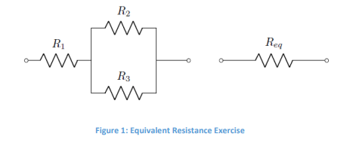

From this task, we observed that the measured value and the code value are almost the same. The measured value is only slightly below the code value. To find the equivalent resistor, we used the formula $\frac{1}{R_{eq}}=\frac{1}{R_{1}}+\frac{1}{R_{2}}$. We built the circuit on NI Elvis and observed that our measured value and code value are slightly off, however, we can consider these values the same.

|  |  |  |
| --- | --- | --- |
| **Resistor** | **Measured Value** | **Code Value** |
| *Req* | 4.9277 kΩ | 4950 Ω |

Table 2: Measured and Code Values of Equivalent Resistance [Ohm]

**TASK 2: Measuring Capacitances**

According to the capacitance code, the theoretical value of *C1* is 1 µF. We connected the capacitor to NI Elvis, by placing one capacitor lead in DUT+ and the other one in DUT-, and observed that the measured value was close to the expected value.

|  |  |  |
| --- | --- | --- |
| **Capacitor** | **Expected Value** | **Measured Value** |
| *C1* | 1 µF | 1.03 µF |
| *C2* | ― | ― |
| *C3* | ― | ― |

Table 3: Measured and Expected Value of Capacitor [F]

**TASK 3: Measuring Voltages**

**Part A)**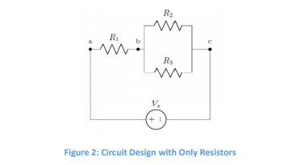

To calculate the theoretical values of *Vab* and *Vbc*, we used Ohm’s law to calculate the current through *Req*, then used that value to calculate the voltage drop between points A and B. We then used Kirchhoff’s Voltage Law to calculate *Vbc*. After calculating the theoretical values, we built the circuit on NI Elvis and obtained the measured values.

|  |  |  |
| --- | --- | --- |
| **Voltage** | **TASK 3-Part A** | **TASK 3-Part B** |
| *Vab* | 3.3333 V | ― |
| *Vbc* | 1.6666 V | ― |
| *Vcd* | N.A. | ― |

Table 4: Theoretical Voltage Values for 5 Volt supply [Volt]

|  |  |  |
| --- | --- | --- |
| **Voltage** | **TASK 3-Part A** | **TASK 3-Part B** |
| *Vab* | 2.4833 V | ― |
| *Vbc* | 1.6583 V | ― |
| *Vcd* | N.A. | ― |

Table 5: Measured Voltage Values for 5Volt supply [Volt]

From this task, we learned how to measure voltage through each circuit element. One multimeter test lead must be connected in V and another test lead must be in COM. In order to get a voltage reading, the voltmeter must be connected in parallel. There is a discrepancy between our measured and theoretical values for *Vab.* This may be due to poor contact of the leads on the resistor. However, our values for *Vbc* are similar. 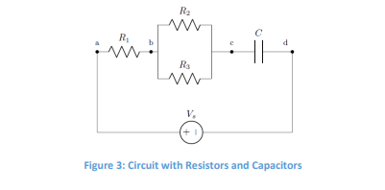

**Part B)**

**TASK 4: Measuring Currents**

To calculate the current, we imputed the voltage values we got into the Ohm’s law and solved for current. After getting the theoretical values, we connected the ammeter in series and collected the values for the currents.

|  |  |  |
| --- | --- | --- |
| **Current** | **Measured Value** | **Calculated Value** |
| *i1* | 0.0002 A | 0.00075 A |
| *i2* | 0.0001 A | 0.0005 A |
| *i3* | 0.0001 A | 0.0005 A |

Table 6: Measured and Calculated Values of Currents [mA]

From this task, we learned how to measure current through each circuit element. The ammeter must be connected in series in order to correctly measure the current, which means that the ammeter must be apart of the circuit. One multimeter test lead must be connected in A and another test lead must be in COM. The measured values are not the same as the calculated values and this is because the ammeter was giving the wrong readings. We talked to the TA about this and he said it was fine because other groups were also getting the same readings as us.

**Conclusions:**

In this lab, we used the workstation NI ELVIS II to wire two types of circuits, one comprised of just resistors and one with resistors and a capacitor. We were able to apply several concepts and strategies in order to measure the resistance, current, voltage, and capacitance. We then were able to compare the measured values with standard calculated values. When compared, our measured values were very accurate. Therefore, we can conclude that the equivalent resistance of a branch must be measured in series to the resistors. The value of a capacitor must be measured separately. Voltage must be measured in parallel. In order to measure current at a specific point, the measuring device has to be apart of the circuit at the point.